Project 01

Deploying a Node.js App Using Minikube Kubernetes

Overview
This project guides you through deploying a Node.js application using Minikube Kubernetes. You'll use Git for version control, explore branching and fast-forward merges, and set up Kubernetes services and deployment pods, including ClusterIP and NodePort service types.

Prerequisites
- Minikube installed
- kubectl installed
- Git installed
- Node.js installed (https://nodejs.org/en/download/package-manager/all#debian-and-ubuntu-based-linux-distributions)

Project Steps

1. Set Up Git Version Control
1.1. Initialize a Git Repository
1.2. Create a Node.js Application
1.3. Commit the Initial Code
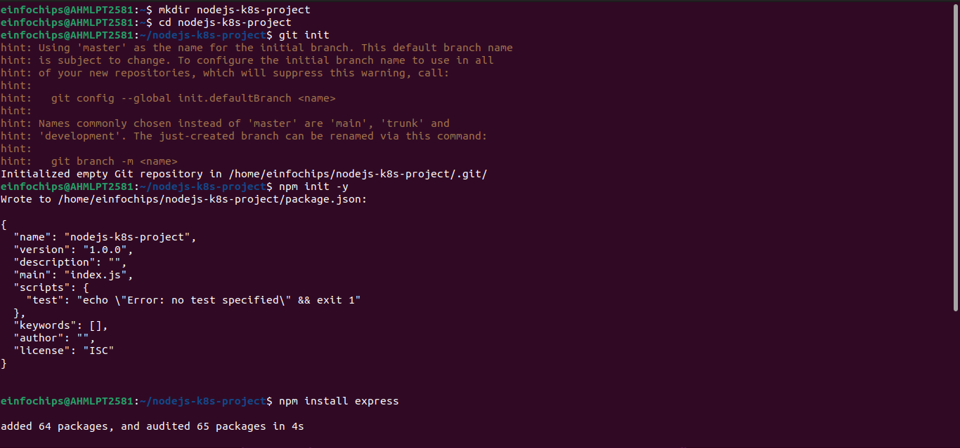

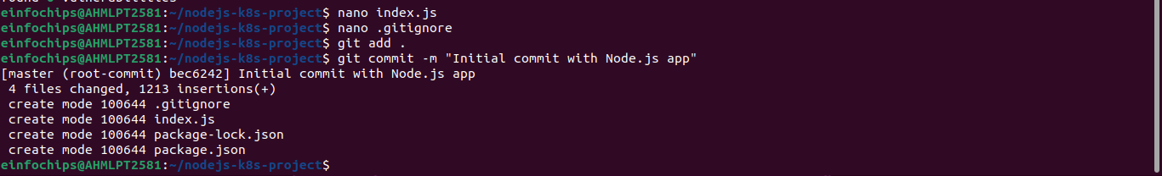

2. Branching and Fast-Forward Merge
2.1. Create a New Branch
2.2. Implement a New Route
2.3. Merge the Branch Using Fast-Forwar

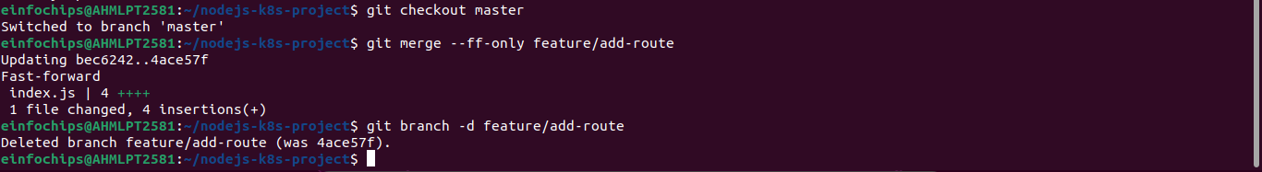

3. Containerize the Node.js Application
3.1. Create a Dockerfile
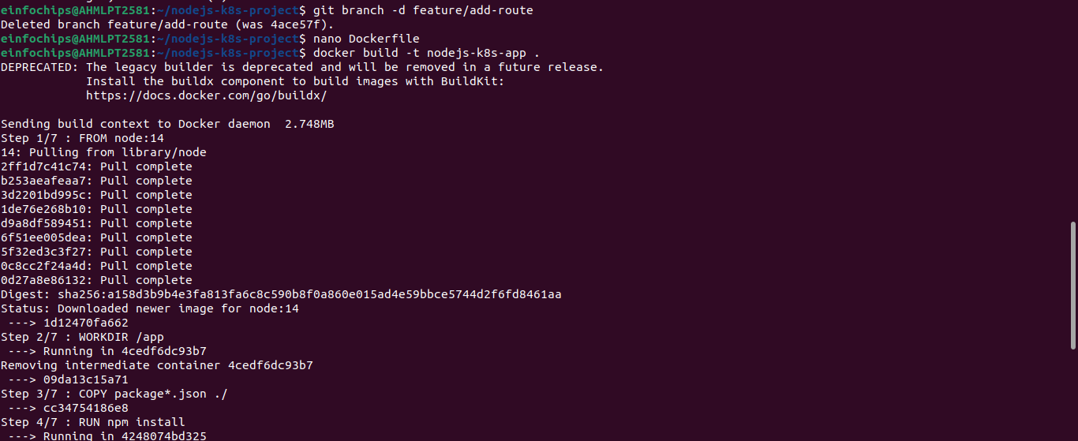
3.2. Build and Test the Docker Image

4. Deploying to Minikube Kubernetes
4.1. Start Minikube
4.2. Create Kubernetes Deployment and Service Manifests
4.3. Apply Manifests to Minikube
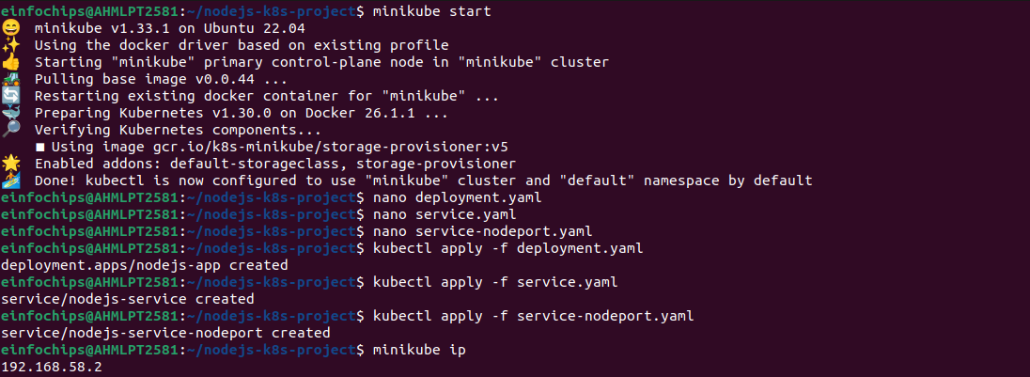
4.4. Access the Application

Making Changes to the App and Redeploying Using Kubernetes

6. Making Changes to the Node.js Application
6.1. Create a New Branch for Changes
6.2. Update the Application
6.3. Commit the Changes

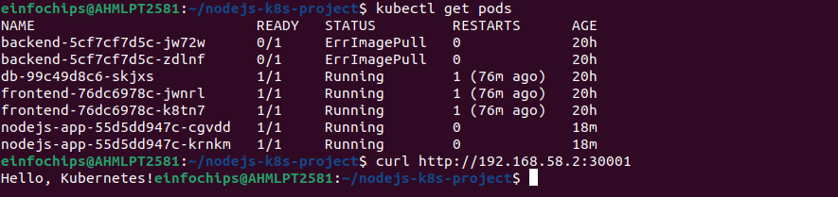

7. Merge the Changes and Rebuild the Docker Image
7.1. Merge the Feature Branch
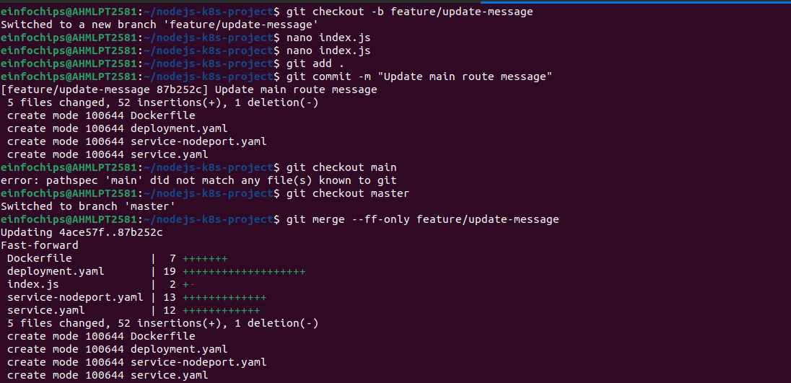
7.2. Rebuild the Docker Image

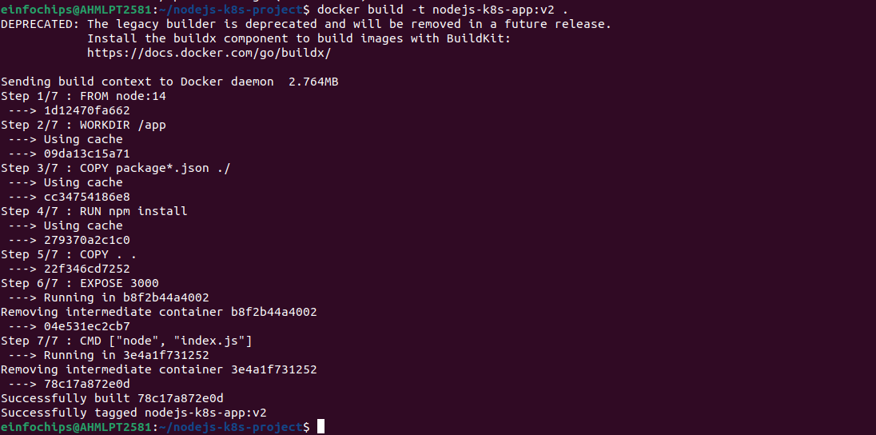

8. Update Kubernetes Deployment
8.1. Update the Deployment Manifest
8.2. Apply the Updated Manifest
8.3. Verify the Update

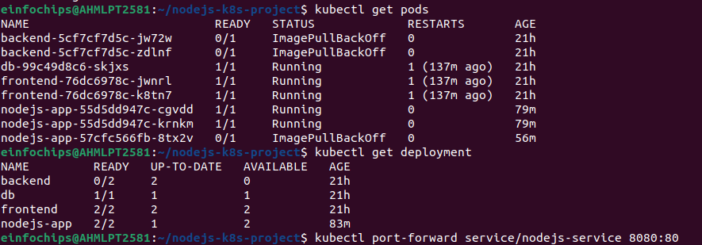

9. Access the Updated Application
9.1. Access Through ClusterIP Service
9.2. Access Through NodePort Service
Project 02

Deploying a Python Flask App Using Minikube Kubernetes

Overview
This project guides you through deploying a Python Flask application using Minikube Kubernetes. You'll use Git for version control, explore branching and fast-forward merges, and set up Kubernetes services and deployment pods, including ClusterIP and NodePort service types.

Prerequisites
- Minikube installed
- kubectl installed
- Git installed
- Python installed

Project Steps

1. Set Up Git Version Control
1.1. Initialize a Git Repository
1.2. Create a Python Flask Application
1.3. Commit the Initial Code

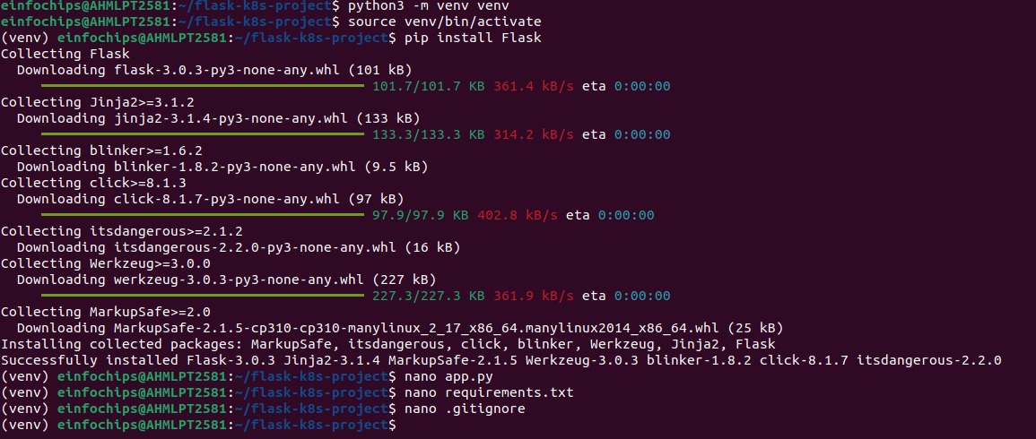

2. Branching and Fast-Forward Merge
2.1. Create a New Branch
2.2. Implement a New Route
2.3. Merge the Branch Using Fast-Forward
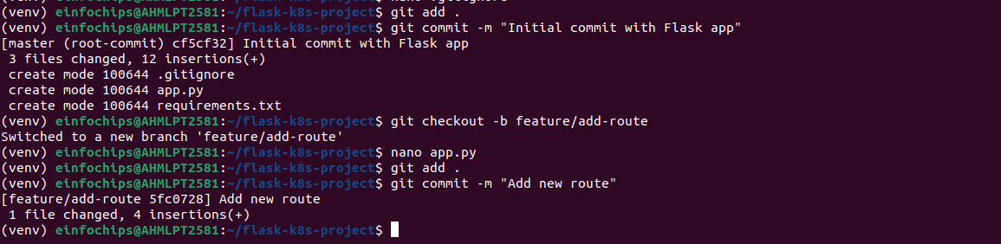
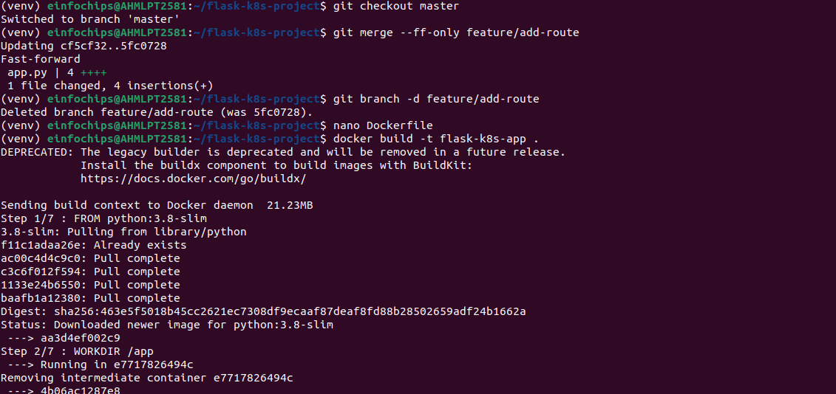

3. Containerize the Flask Application
3.1. Create a Dockerfile
3.2. Build and Test the Docker Image

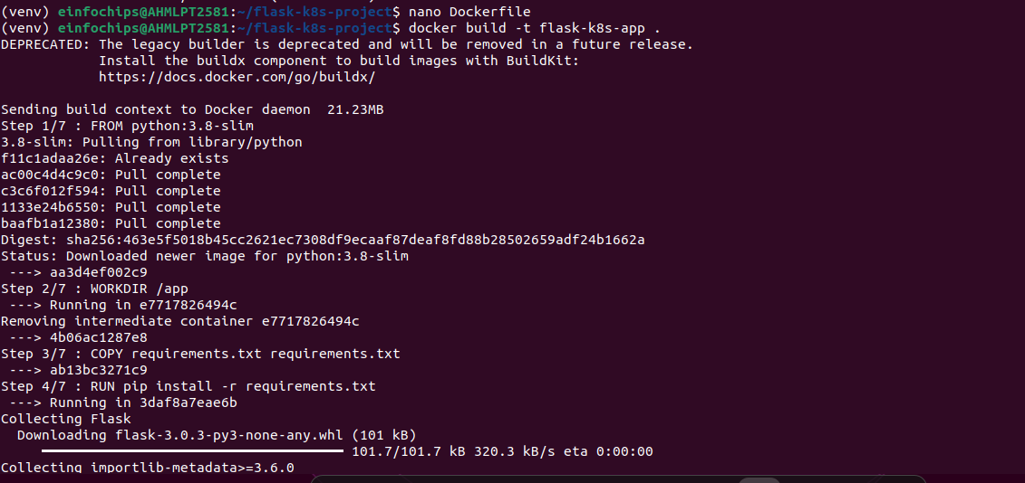

4. Deploying to Minikube Kubernetes
4.1. Start Minikube
4.2. Create Kubernetes Deployment and Service Manifests
